

Department of Computer Engineering
Cairo University
Faculty of Engineering

ELC 3252 – Spring 2025
Digital Communications

Assignment #2
Matched Filters

Submitted to
Dr. Mai Badawi
Dr. Hala
Eng. Mohamed Khaled
Submitted by

Name | Sec | BN
Ahmed Hamed Gaber | 1 | 3
Somia Saad El-Shemy | 1 | 26

Contents
Part 1 (Hand Analysis) 3
Part 2 (Hand Analysis) 5
Part 2 (Simulation) 8
Output of Receive Filters 8
BER vs E/N0 9
Q5 Answer 10
Q6 Answer 10
Code (Python) 10

Part 1 (Hand Analysis)

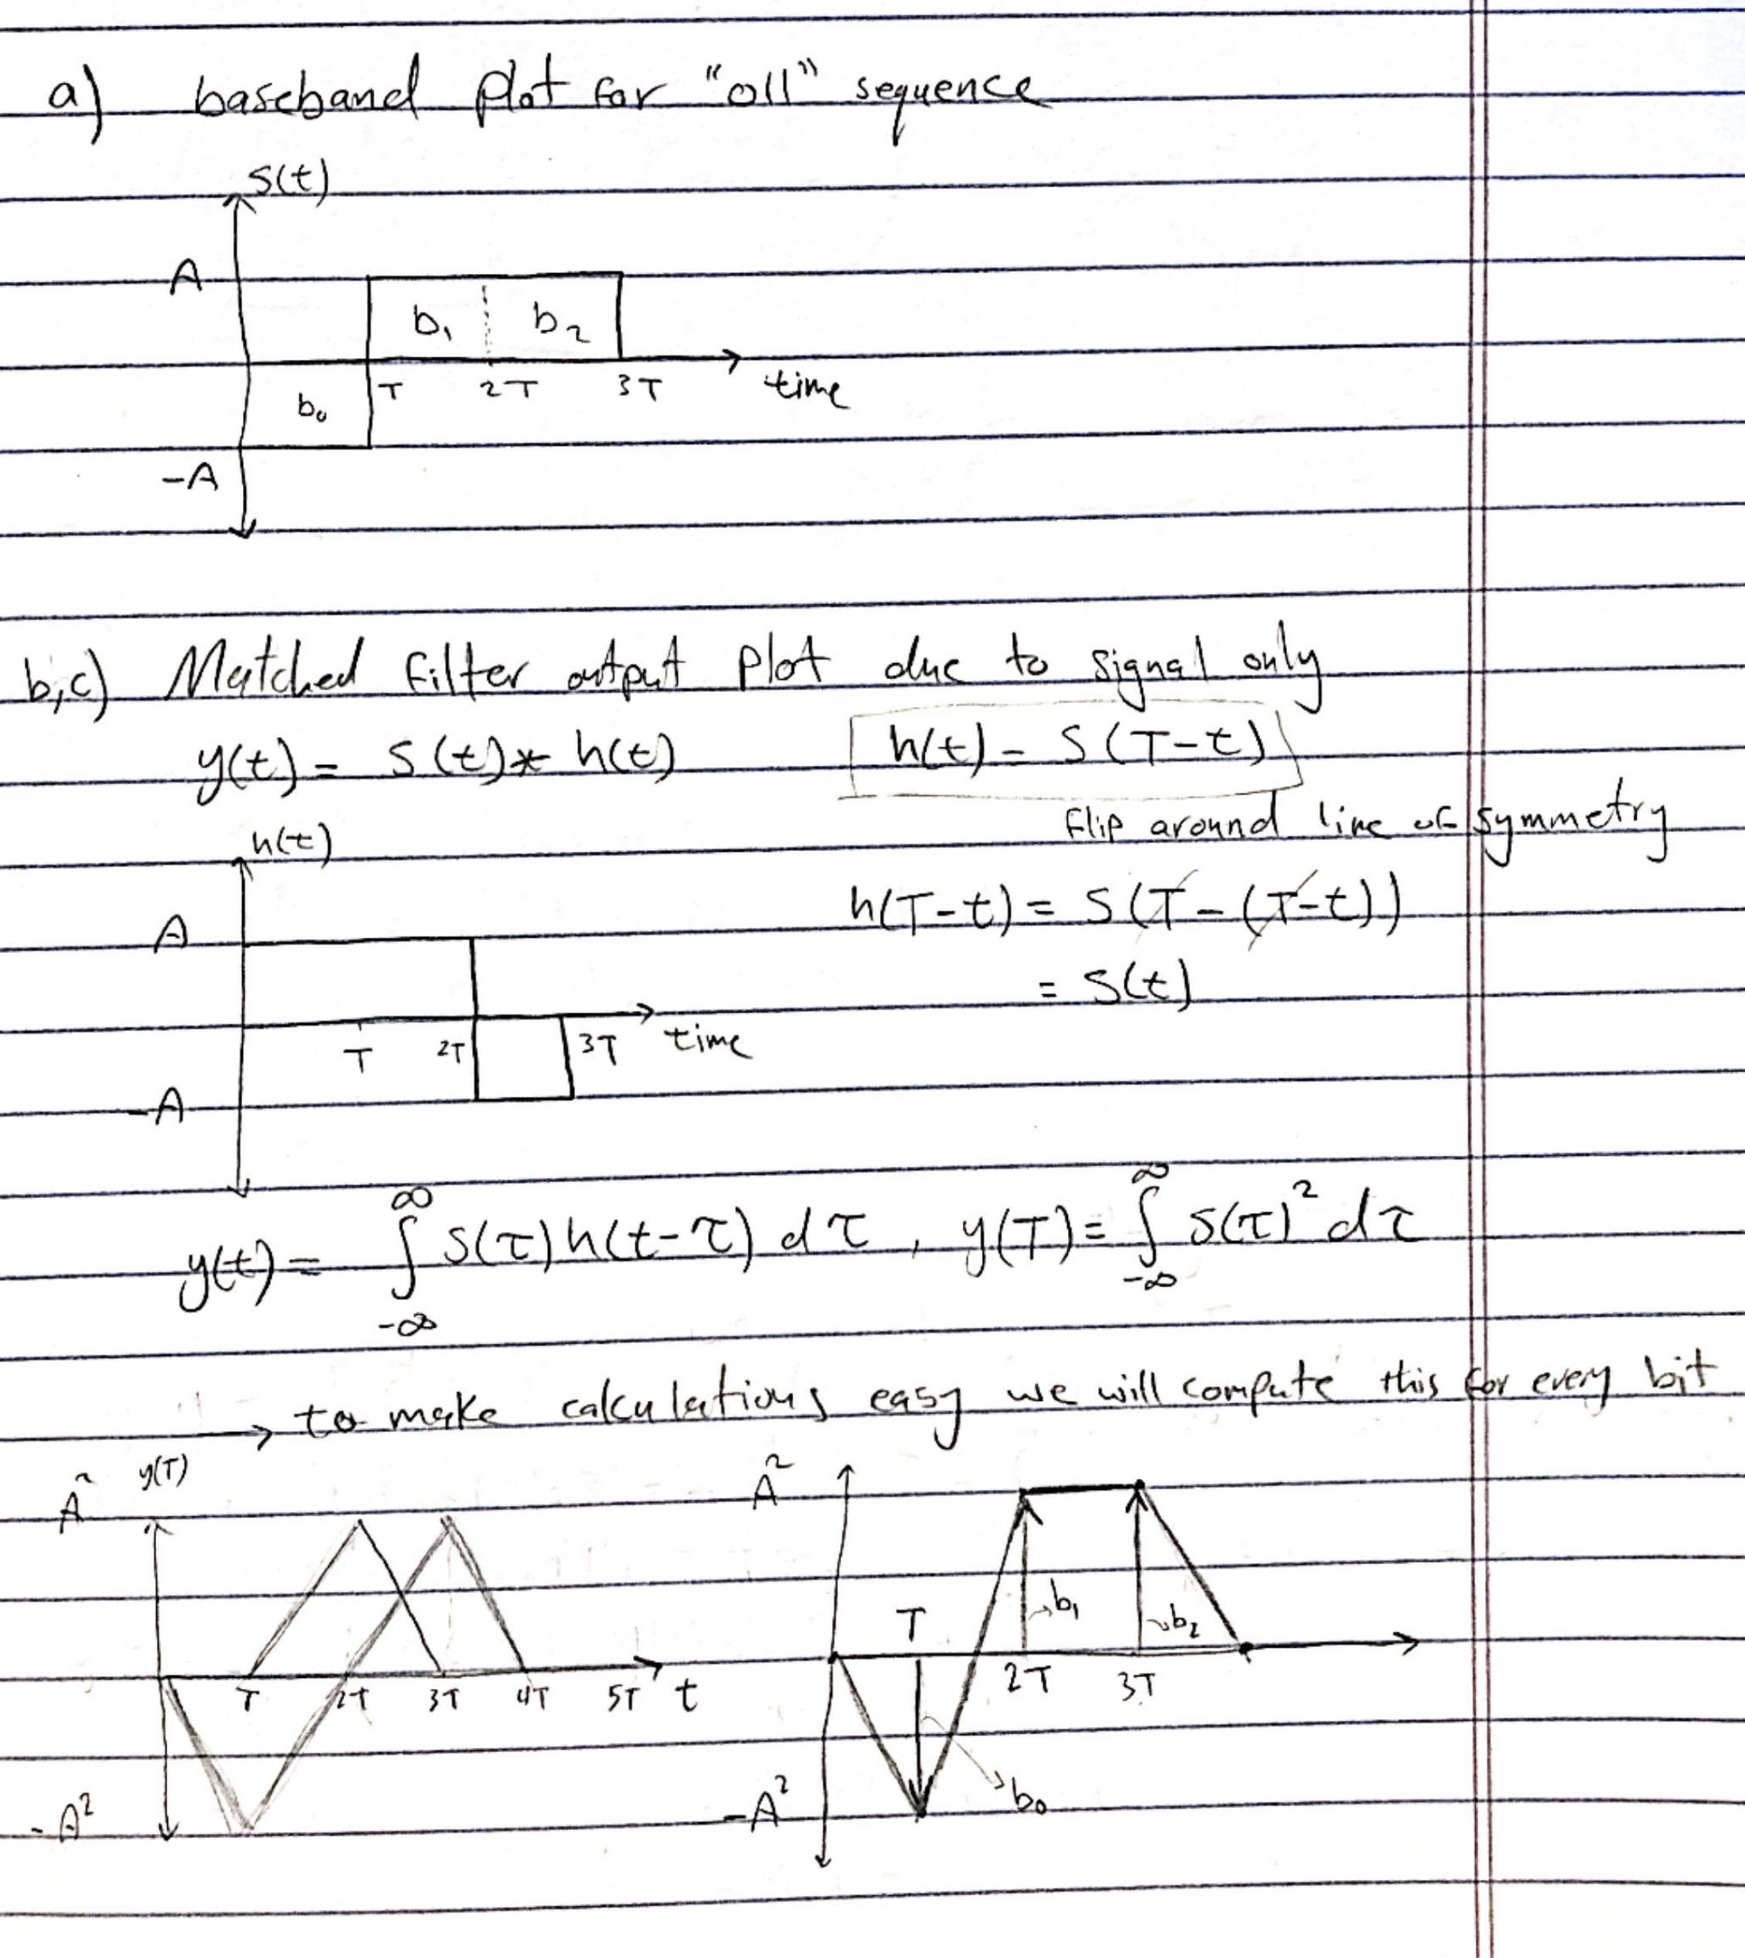



Part 2 (Hand Analysis)
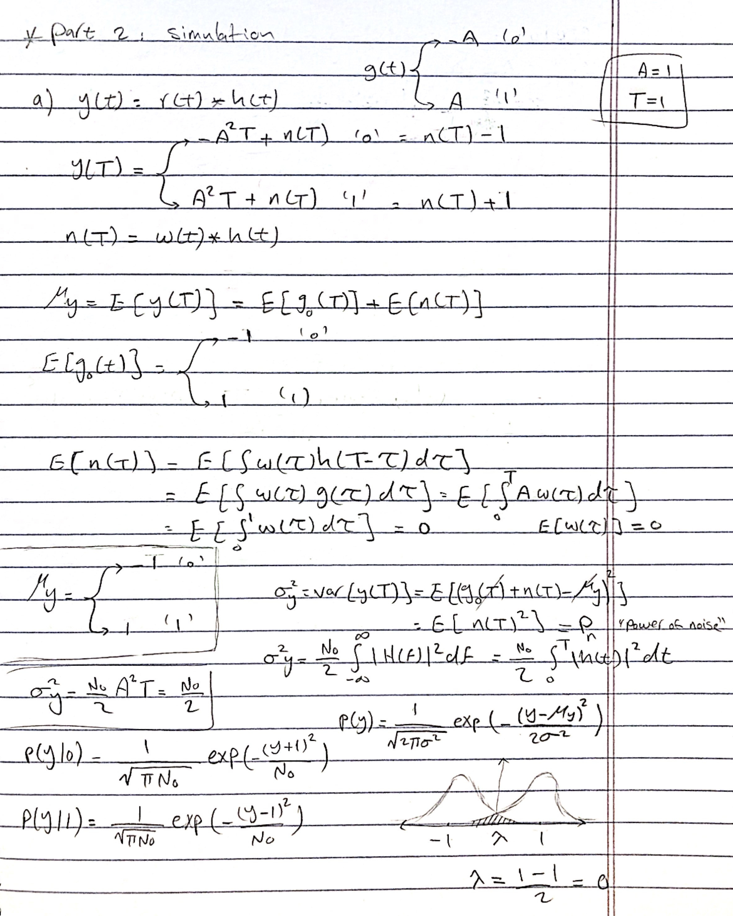
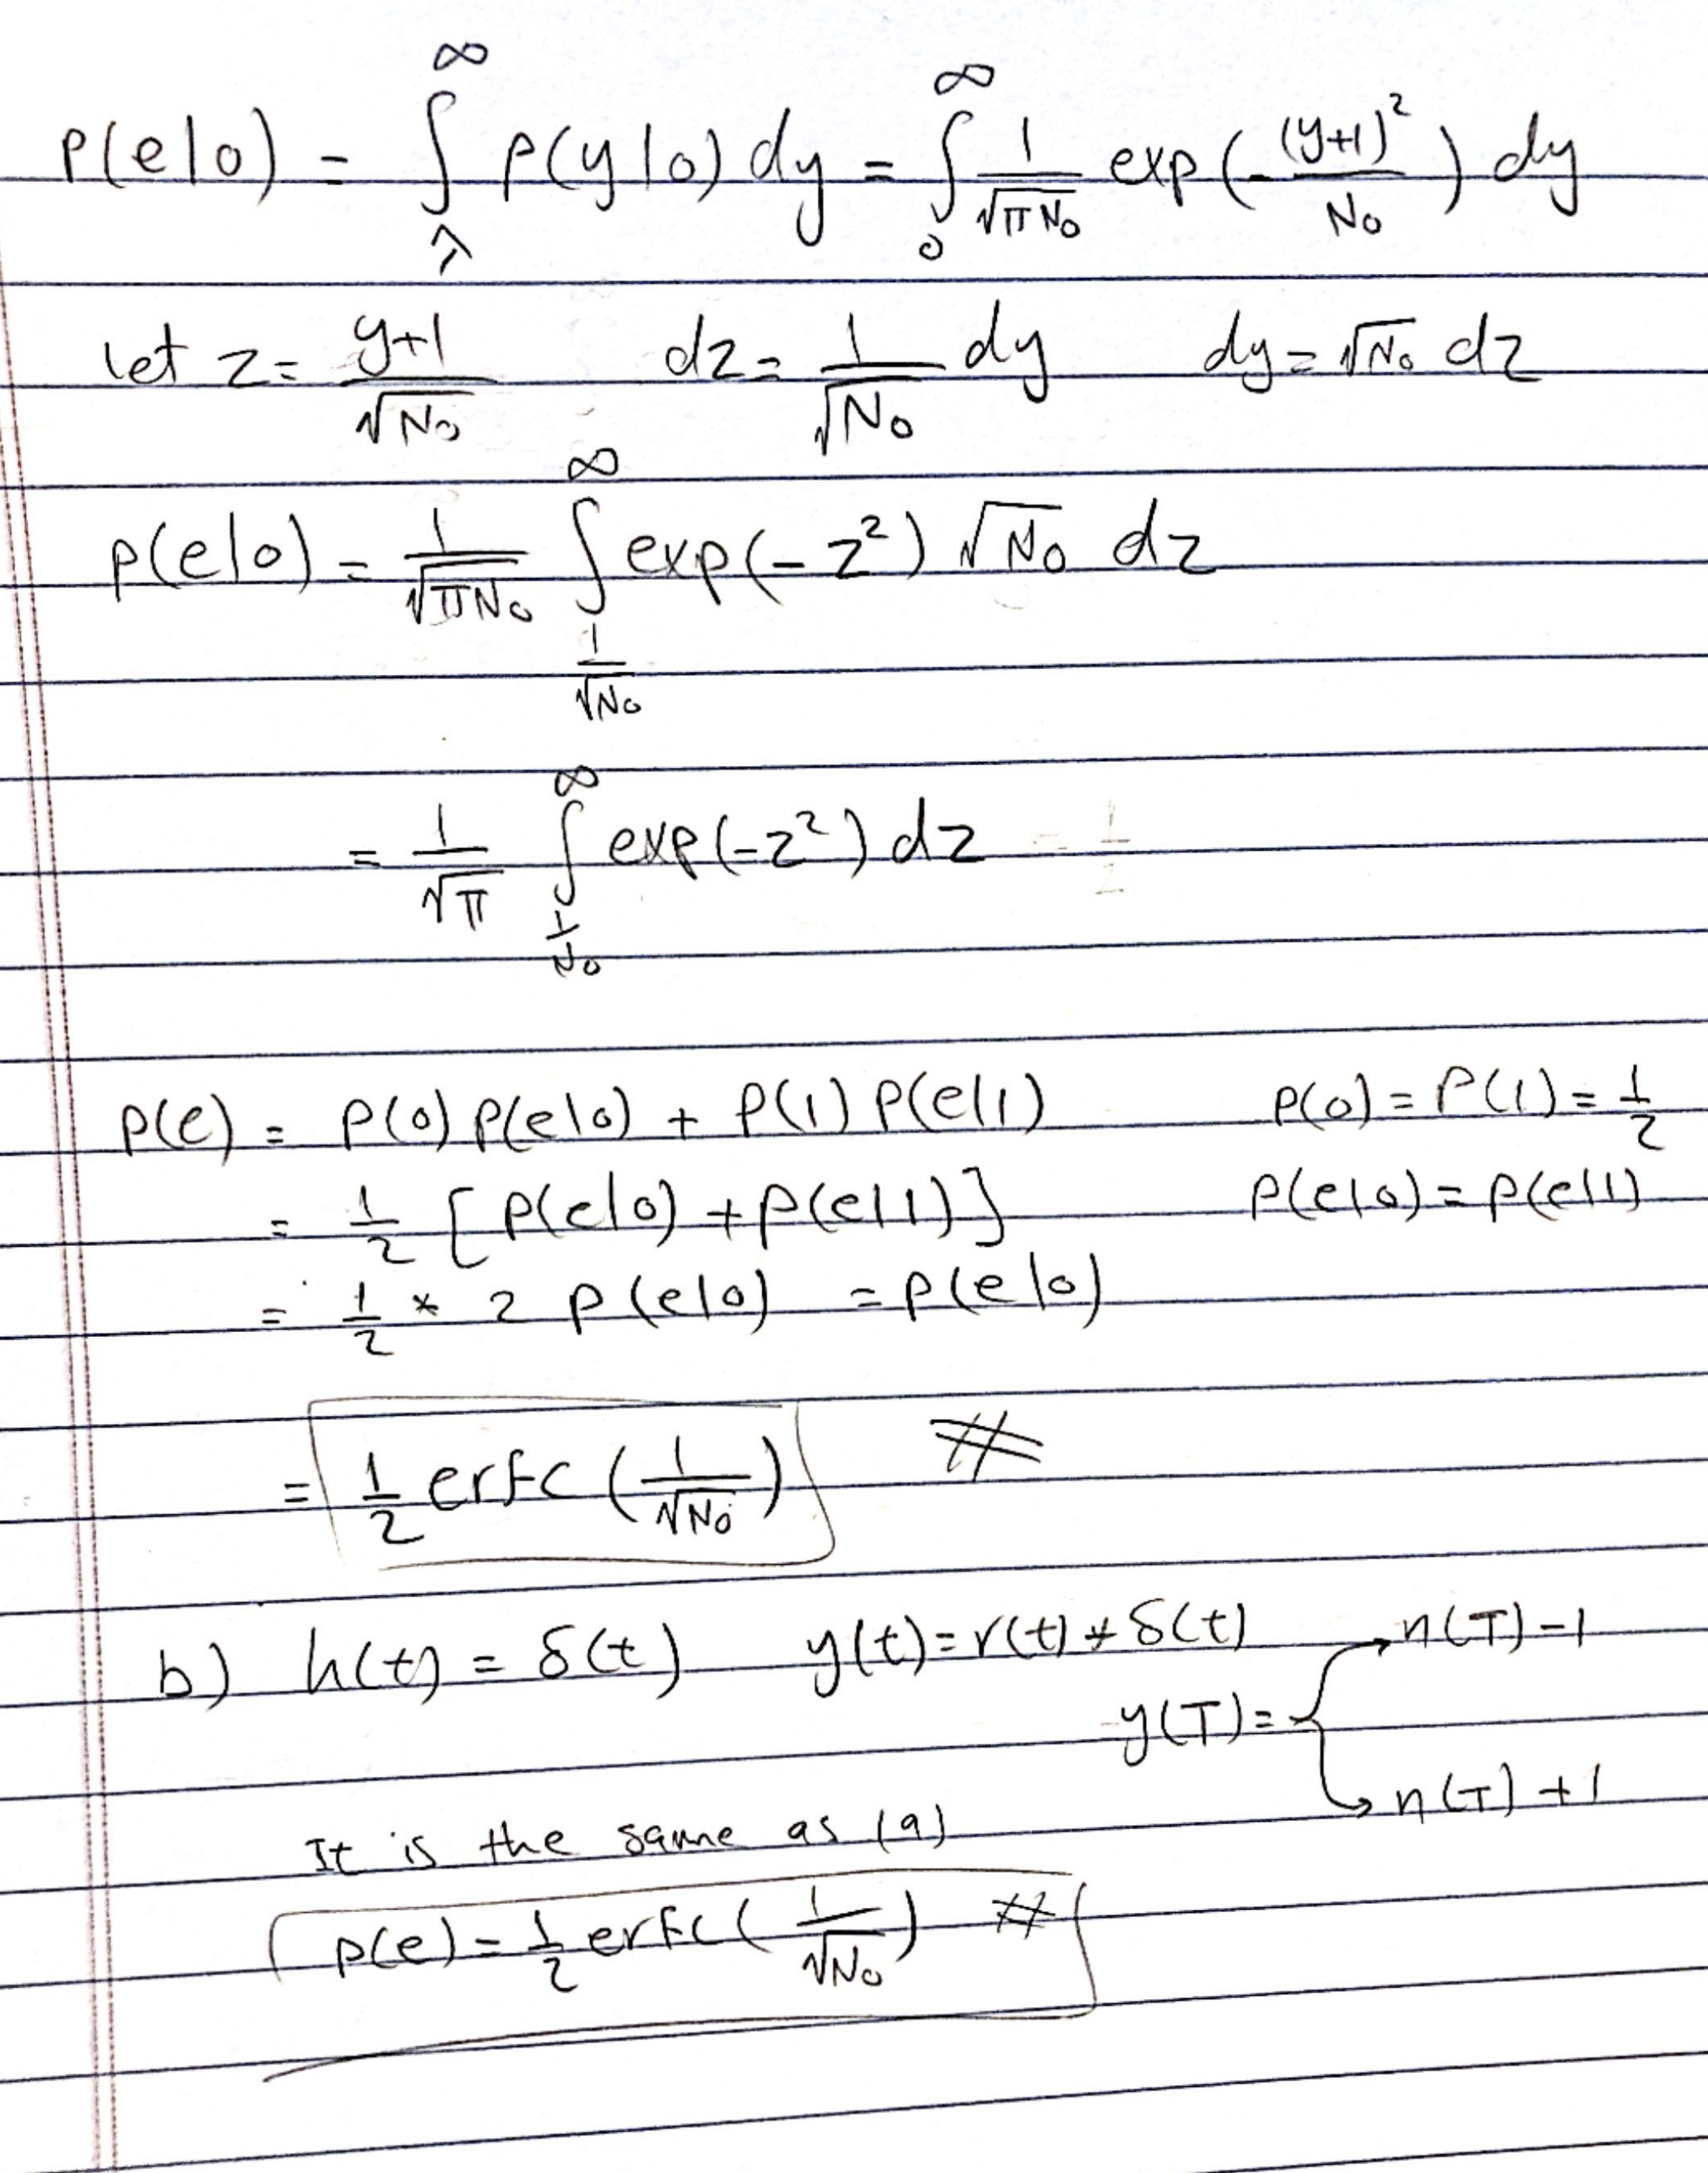
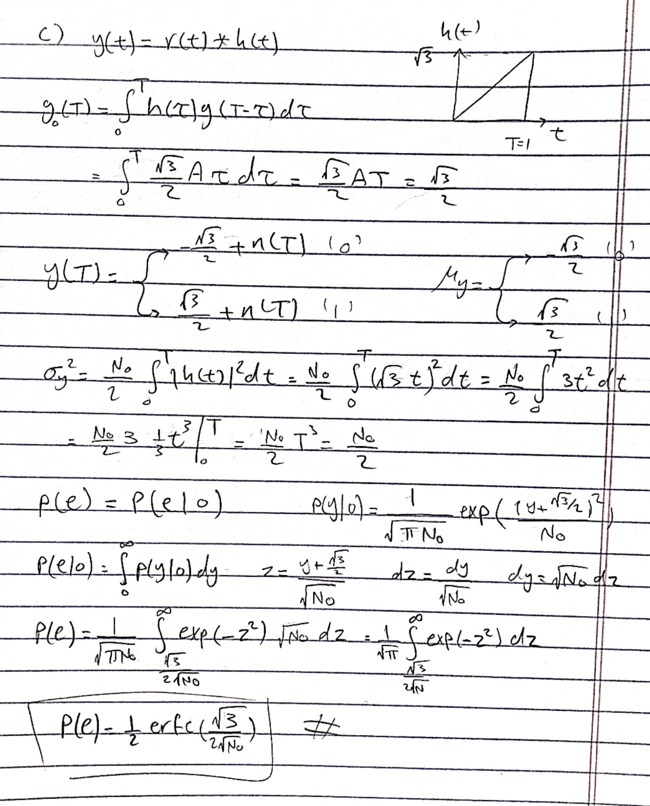

Part 2 (Simulation)

Output of Receive Filters
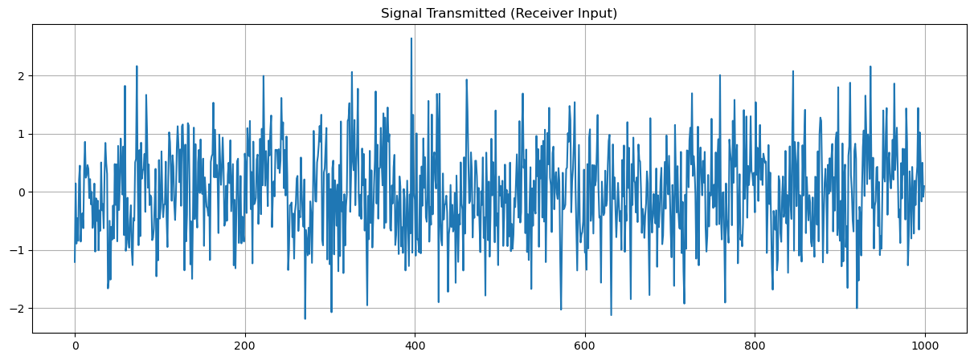
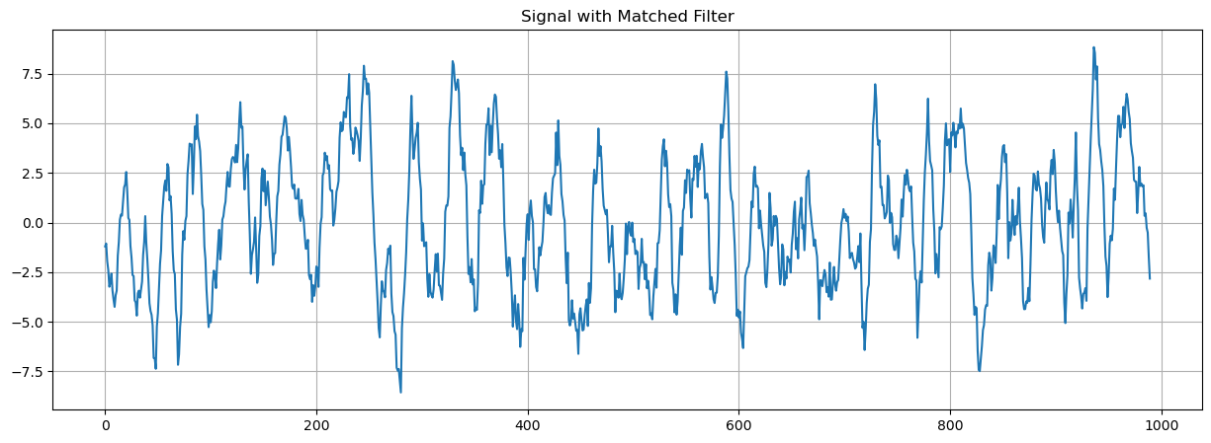
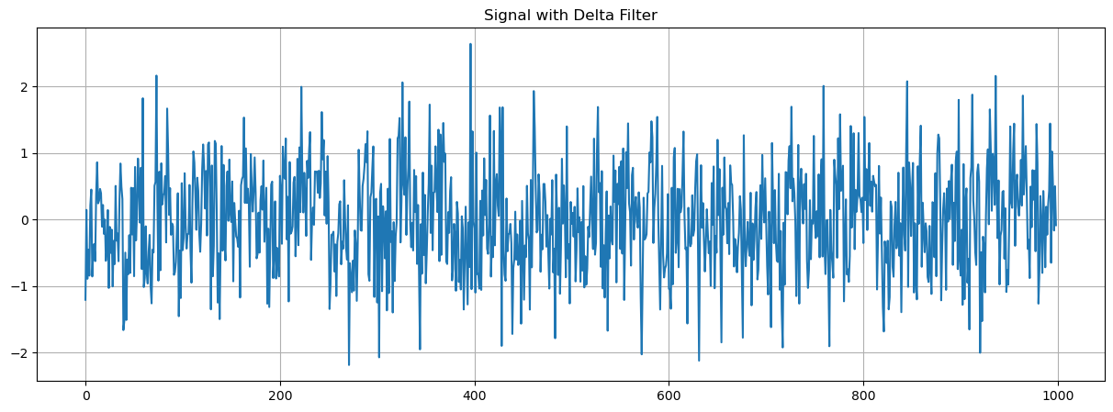
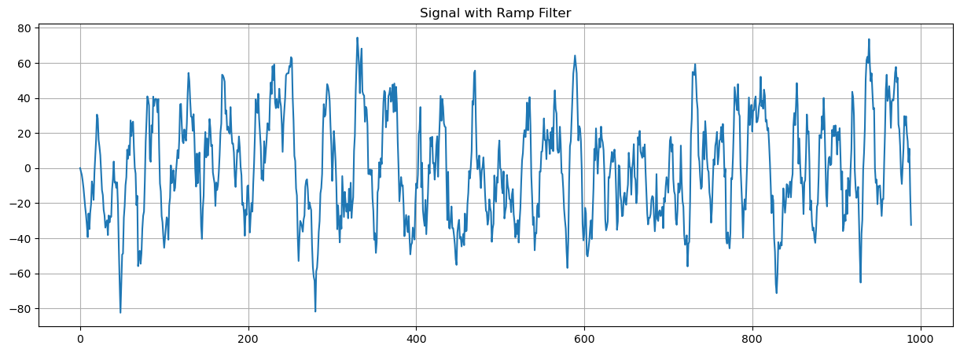
Comment:
The plots shows that matched filters give the best results, and delta (pulse) filters give the worst results.

BER vs E/N0
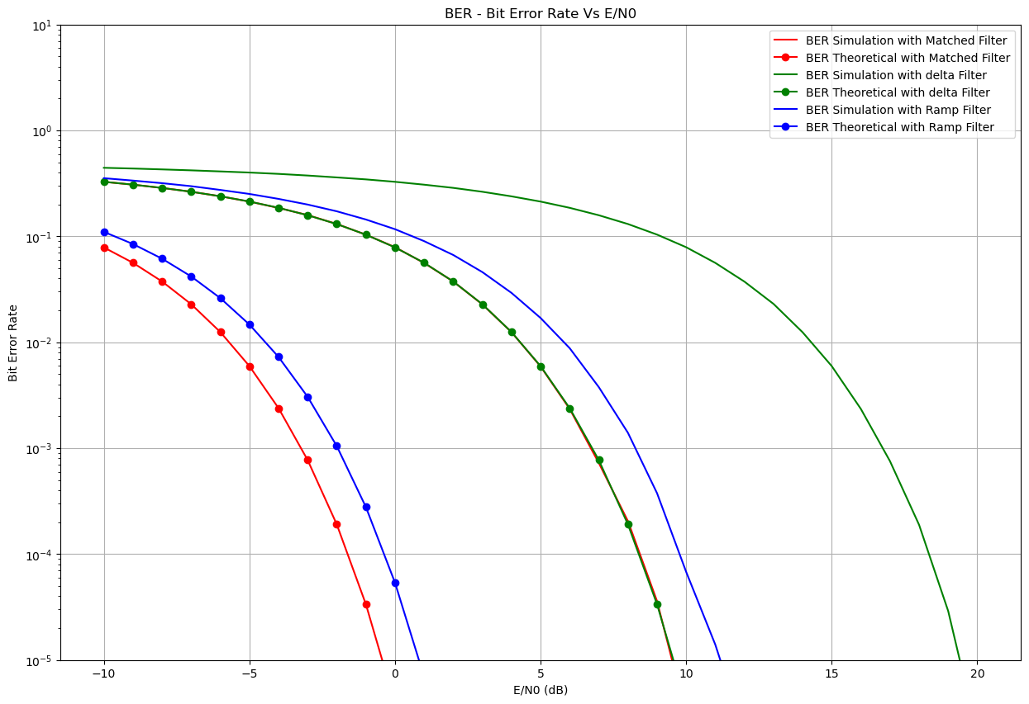
Comment:
It seems that simulated values are the same as theoretical but shifted right. Simulated values are enhanced when increasing number of bits.

Q5 Answer

It is obvious that BER is a decreasing function of E/N0, because increasing E/N0 means that signal energy is bigger compared to noise energy, which means that probability of error will decrease.

Q6 Answer

It is obvious that it is Matched Filters, because matched filters multiply each value in the signal with a suitable value, high value with a high value and low value with a low value, which makes the original signal preserved, therefore resulting in lower BER values.

Code (Python)
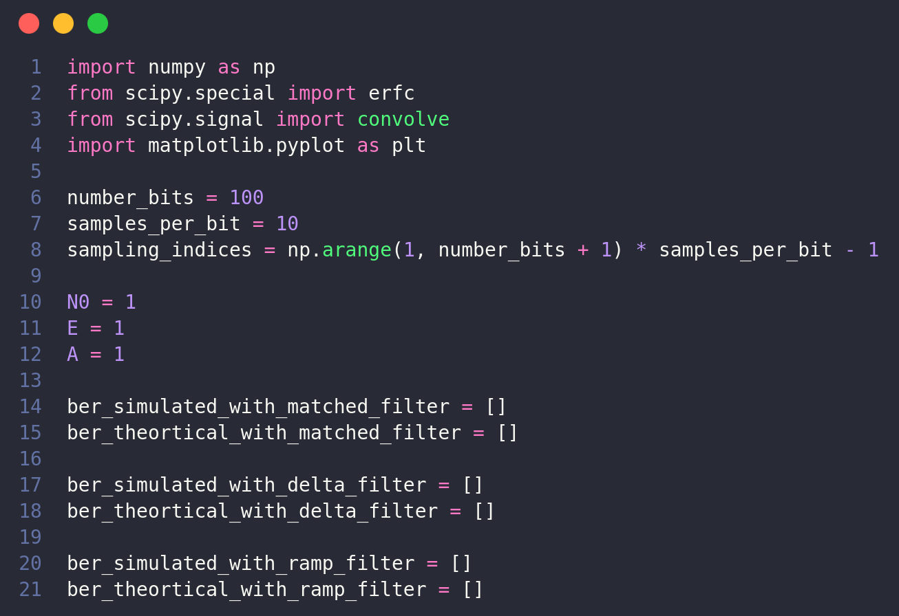
Imports and global variables

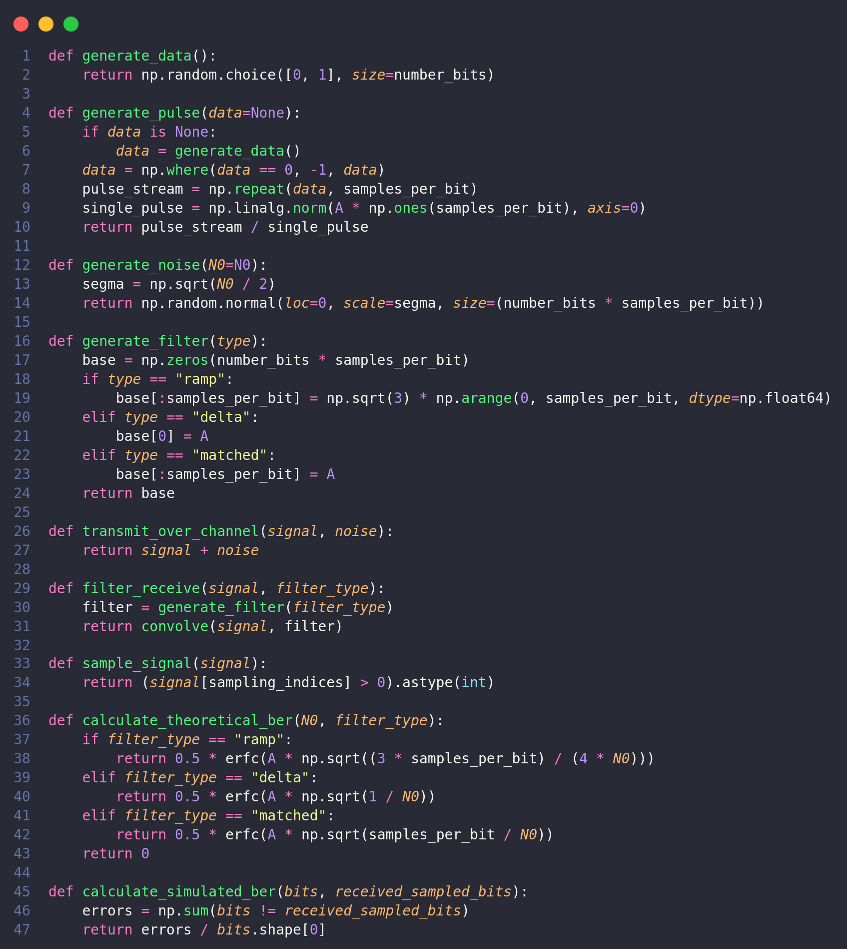
Functions
Simulation & Ploting
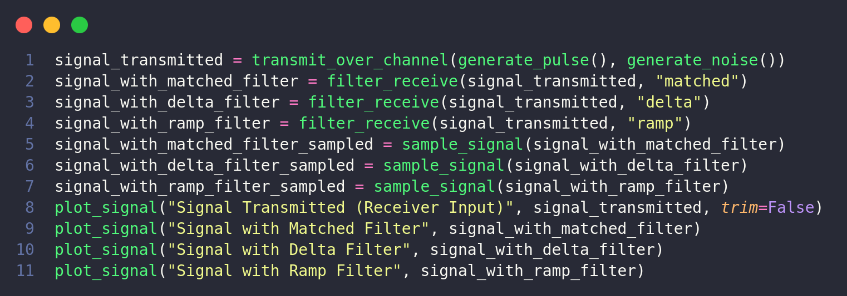
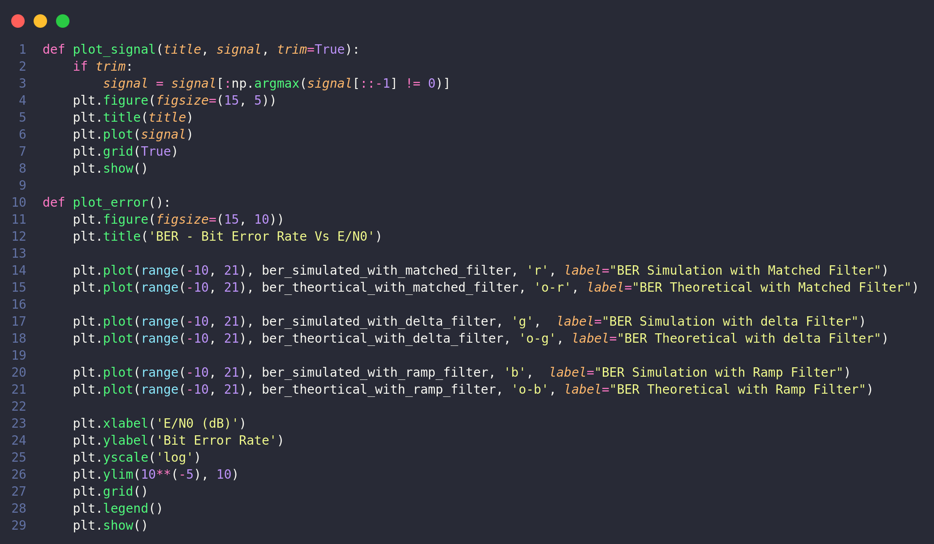
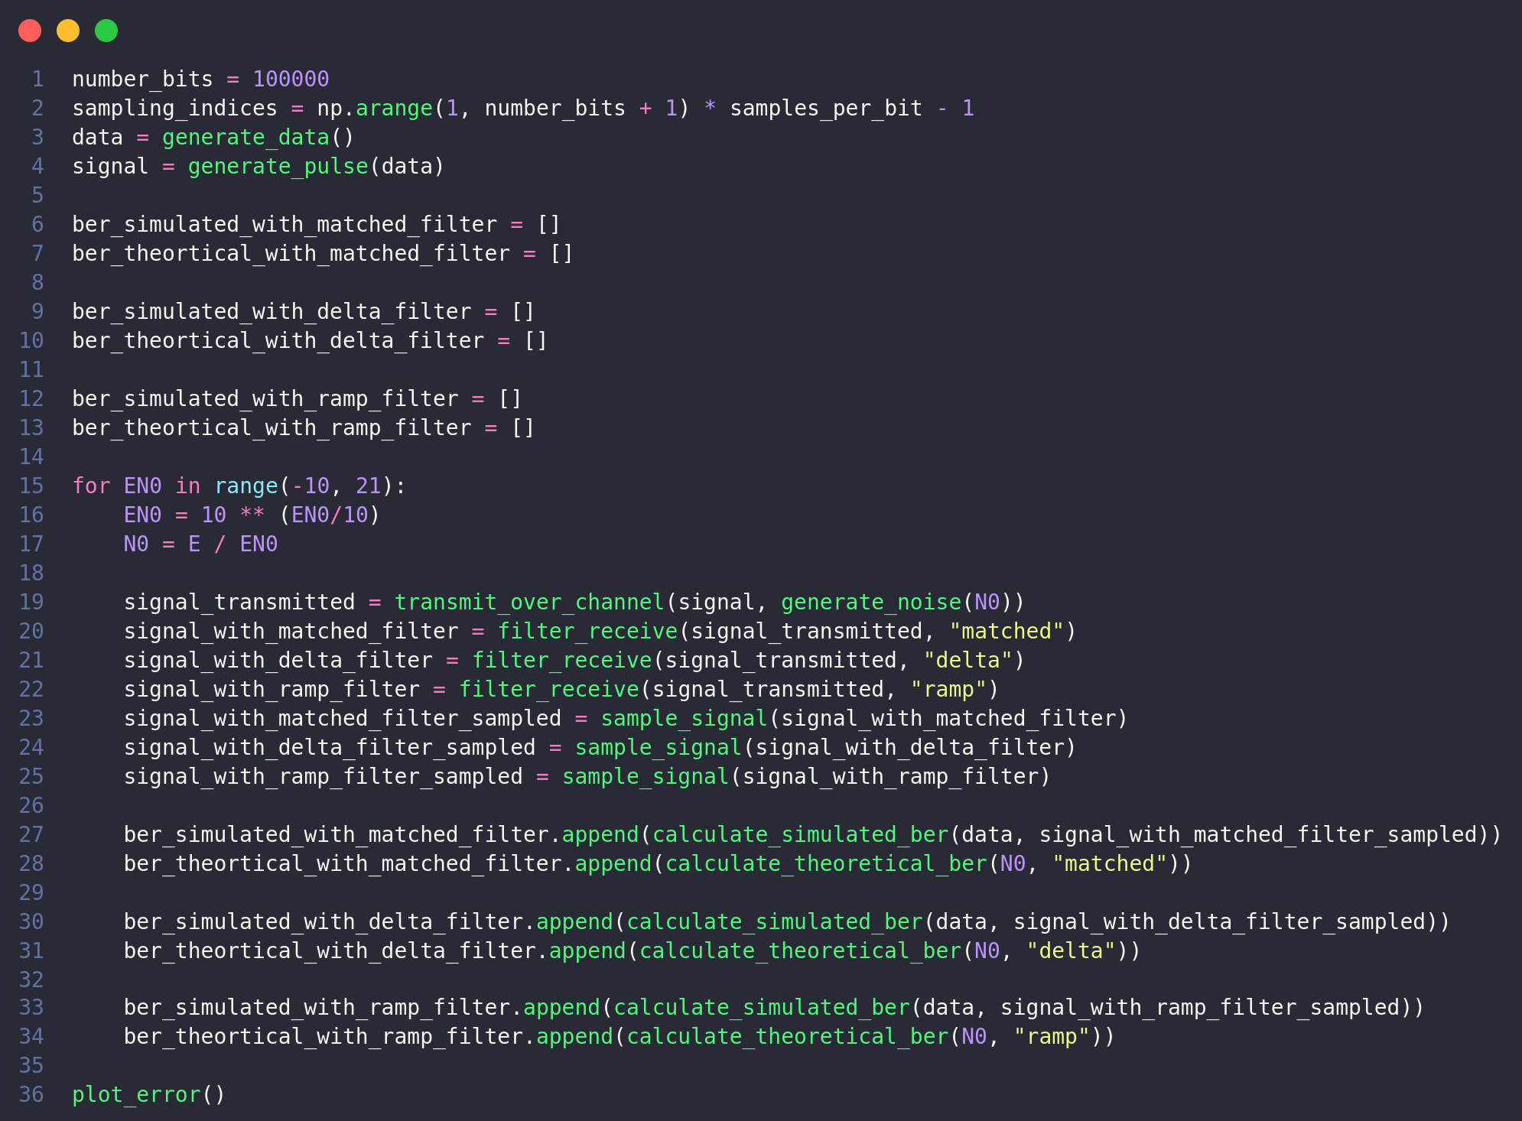
BER Error

